# **Project: Payment Modes System**

Contact Information:

* Name: Sahil Saini
* Email: sahil.saini@effigo.tech

## **Project Overview**

The Payment Modes System streamlines payment processing for invoices. Users can choose payment options such as Cheque, providing relevant details like Cheque No, Bank Name, Cheque Date, etc. The system ensures accurate record-keeping and verification of payments against invoices.

## **Functional Requirements**

**Payment Page:**

* There will be dummy list of invoice numbers upon clicking on the invoice number
* User will get directed to the payment creation page
* Invoice number should have data attached in the database to display invoice information
* Get it reviewed

### **Payment Creation**

* Select Payment Options:
  + Dropdown menu for selecting payment options.
  + Display fields based on the chosen payment option.
* Cheque Number(mandatory field):
  + Capture cheque number.
  + Contains only integer 6 digits
* Cheque Date(Mandatory field):
  + Should not be past the current date
  + Contains calender to enter date
* Cheque Expiry Date(mandatory field):
  + Should not past the cheque date
  + Contains calender to enter date
* Bank Name(Mandatory field):
  + It can be a drop down field and user will select the bank
  + If bank name not mentioned in the drop down user can manually enter
* Description(mandatory field):
  + User can enter description of the payment
* upload(Button mandatory)
  + Upload relevant documents (e.g., scanned copy of the cheque) in PDF or Word format.
  + There will be a button to upload scanned copy either from drive or local device
* Submit (button):
  + Data should be stored in the database
  + Upon clicking on this button user will be redirected back to the payment page and can create payment or see the list of payment
* Back(Button):
  + Navigate back to payment page
  + Get this page reviewed
  + 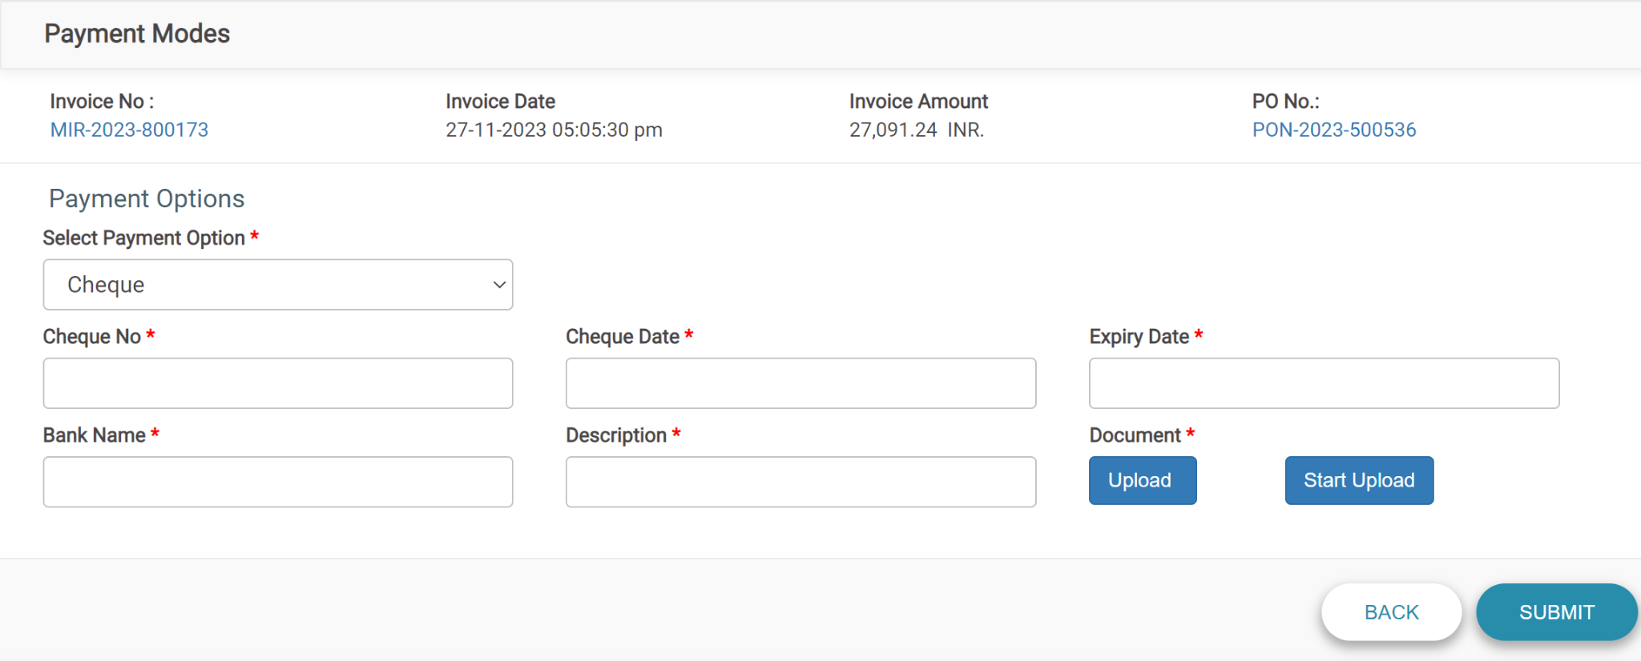

### **Payment Listing**

* Listing of the details
* Start Date
  + Fetch payments starting from which date
  + Date should be more than current date
* End Date
  + Fetch payments till this date
  + Should not be greater than today’s date
* Vendor Name
  + It will be a drop down
  + List of vendors
* Search Button
  + After clicking on this button List will be filtered depending on start date ,end date and vendor’s name
* Clear Button
  + To clear start date , end date and vendor name to null
* Export
  + Export the payment list in excel form
* Company code
  + Contains only integer values
  + Filter is provided for filtering specific data
* Vendor Code
  + Contains only Uppercase alphabets and integers
  + Filter is provided for filtering specific data
* Vendor Name
  + Uppercase letters only
  + Filter is provided for filtering specific data
* Clearing Date
  + Contains calender date
  + Filter is provided for filtering specific data
* Clearing Document Number
  + Contains Long int
  + Filter is provided for filtering specific data
* Fl Document Number
  + Contains only Long int
  + Filter is provided for filtering specific data
* Fl Document Year
  + 4 digit int
  + Filter is provided for filtering specific data
* Fl Posting Date
  + Contains calender date
  + Filter is provided for filtering specific data
* Fl Document Date
  + Contains calender date
  + Filter is provided for filtering specific data
* Invoice Number
  + Numeric values or AlphaNumeric values
  + Can also have null
  + Filter is provided for filtering specific data
* Invoice Amount
  + Long int
  + Positive and negative values
  + Filter is provided for filtering specific data
* Pagination
  + To decide how many rows to show in one page
* Back(button):
  + Clicking on back will take user back to payment mode page
  + Get this page reviewed
* 